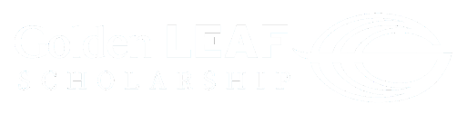

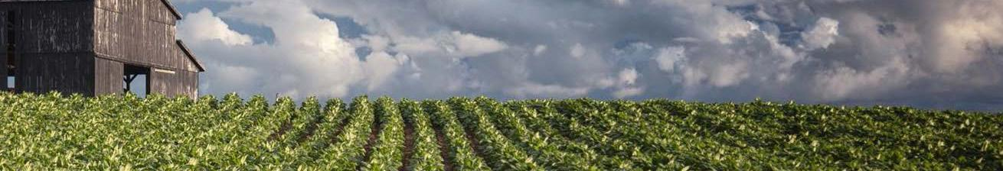
Qualifying Counties
2023-2024 Community Colleges Scholarship

Alamance
Alexander
Alleghany
Anson
Ashe
Avery
Beaufort
Bertie
Bladen
Brunswick
Buncombe
Burke
Cabarrus
Caldwell
Camden
Carteret
Caswell
Catawba
Chatham
Cherokee
Chowan
Clay
Cleveland
Columbus
Craven
Cumberland
Currituck
Dare
Davidson
Davie
Duplin
Edgecombe
Franklin
Gaston
Gates
Graham
Granville
Greene
Halifax
Harnett
Haywood
Henderson
Hertford
Hoke
Hyde
Iredell
Jackson
Johnston
Jones
Lee
Lenoir
Lincoln
Macon
Madison
Martin
McDowell
Mitchell
Montgomery
Moore
Nash
Northampton
Onslow
Orange
Pamlico
Pasquotank
Pender
Perquimans
Person
Pitt
Polk
Randolph
Richmond
Robeson
Rockingham
Rowan
Rutherford
Sampson
Scotland
Stanly
Stokes
Surry
Swain
Transylvania
Tyrrell
Union
Vance
Warren
Washington
Watauga
Wayne
Wilkes
Wilson
Yadkin
Yancey
This list is effective for new scholarships awarded on or after August 1, 2023. Scholarships are limited to students who demonstrate financial need and reside in the qualifying counties listed. A scholarship recipient who resides in a qualifying county upon initial award (including awards made prior to August 1, 2023), will retain eligibility and will be eligible for renewal awards if the student’s place of residence is within the state of North Carolina and other scholarship eligibility criteria are met. The Golden LEAF Foundation Board reserves the right to alter the list and policies.
Reviewed 4/2023

